Learning activity : Electricity

In this activity we try to show how electricity works in a safe and understandable way for the children.

We divide the pupils in groups of 4, each group has his own little box with materials.

We start with the making of a simple electric circuit: battery, wires, fitting with lamp.

Then we build up: we add more lamps, a buzzers, a switch and try to understand what happens in every step.

After that we test some materials: do they guide the electricity or are they isolators? We do this by puttung the different materials in between the lamp and the battery. In this way children can see directly of the material guids the electricity.

Basic materials for every group:

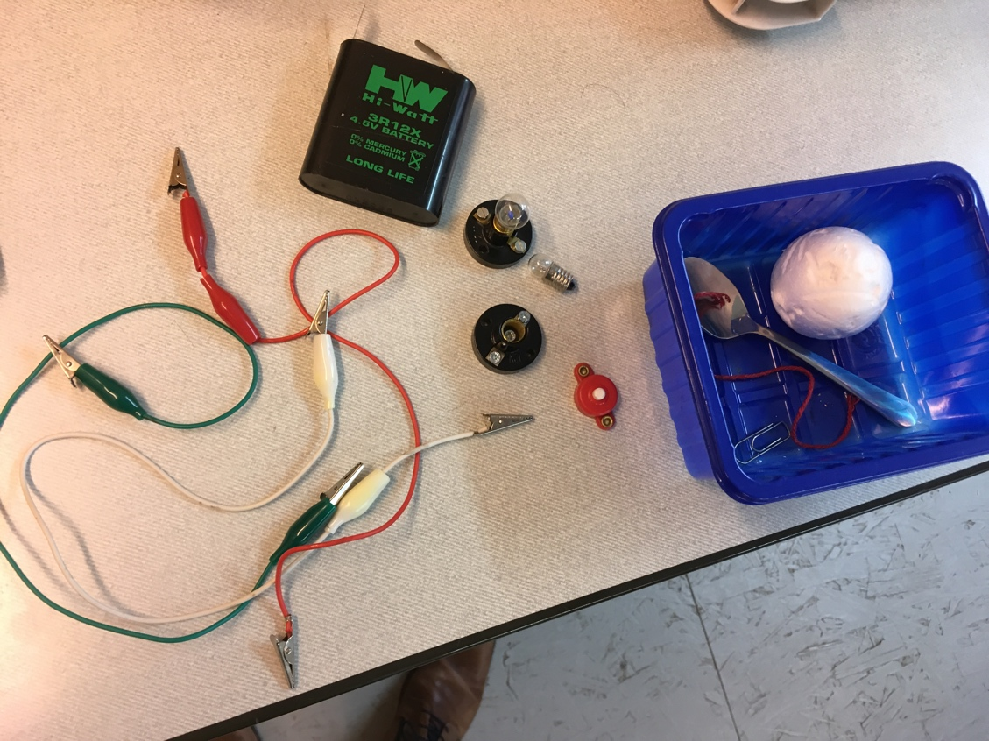

The main purpose of the activity is that children to all the things by themselves, the teacher is just the coach and keeps an eye on safety.

Some pictures from the activity:

