Mental health

Physical and mental well-being go hand in hand. One can affect the other. Stress for example can lead to painful muscle tension whereas continuous headaches may cause people to avoid social contacts, or stress...
Hence the importance of paying sufficient attention to mental health as a pillar of a well-balanced preventive health care.
It would be ideal to start working from early on when values and attitudes are yet being developed and children still are in the process of developing patterns of conduct.
After all they are living in an environment and they are continuously observing how others (peers, youths, adults) deal with issues.
Coaching from close-by in the course of this process while offering interesting alternatives, may work preventively in educating children to grow into well-balanced young people, sporting adequate self-esteem, being well aware of their own capabilities, able to cope with their emotions, and thus - among other things - less dependent on addictions.

"Research has shown that feelings of self-esteem are key elements in preventive care. This starts with developing self-awareness. Children need this in order to learn how to appreciate themselves and others as well. Positive self-awareness leads to greater self-confidence and trust which are necessary to develop and acquire more self-protecting skills." (P,van der kreeft; het gat in de Haag (2001))

With this in mind, in the social skills lessons, we provide children with stimuli offering them a realistic view on their own capabilities and talents, allowing them to gain insight into their own emotional needs and feelings, helping them to dare and ask for targeted help when experiencing psychological problems, getting them to develop an open mind on gender diversity for instance and by doing so easing the process of self-acceptance in case of experiencing one's own "deviancy".
Another important focus of attention teaches children to explore their own emotions and to readjust any imbalances through focusing on breathing and visualization.
Much more even than merely sensible, it is absolutely necessary to educate our children to become mentally sound and independent young people.
We teach them "life skills" (personal as well as social skills)

"Grown-ups need these life skills to cope successfully with our 21st century society." (P,van der kreeft; het gat in de Haag (2001))

The foundation for these life skills is being laid in kindergarten. Miss Krista, kindergarten social skills teacher, teaches personal and social skills through story telling.
Miss Inge teaches social skills in primary school. Our school opted for specialized teachers to teach "life lessons" in order to obtain a strong vertical integration flow.
Individual care gets ample space as well. Whenever children are struggling with mental burdens (due to divorce, grievance, bullying, anguish...) they can recuperate with Miss Inge. Targeted listening, talking, simple techniques can bring about relief from mental burdens.
Naturally, the form teacher is our pupil's first confident. If need be the assistance of Miss Inge is requested. In case of overly complex problems, CLB is called in to explore the possibilities for extra support.

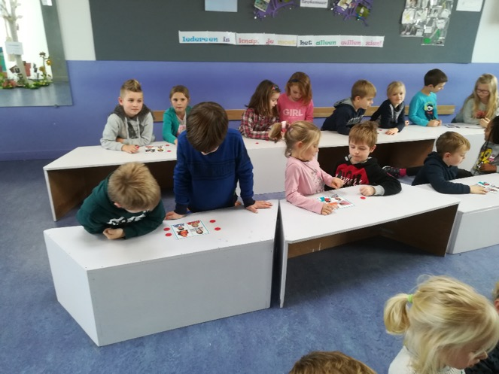

Focus on inner peace through breathing and visualization.
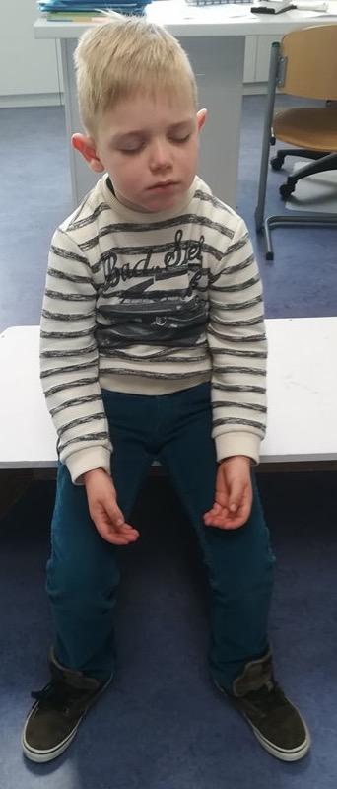
Also small movie

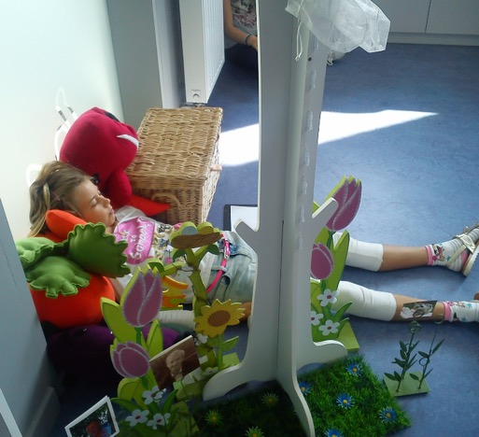

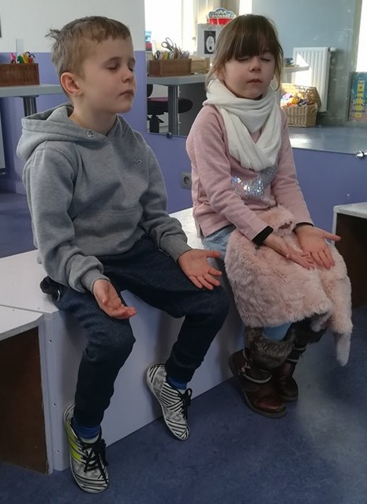

Working with gender diversity, role patterns, diversity

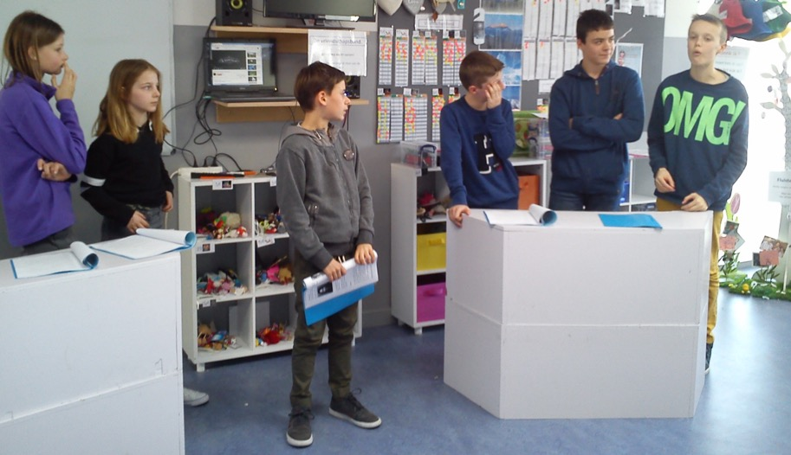

Debate about homosexuality

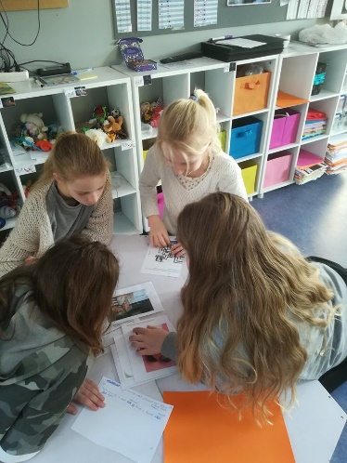

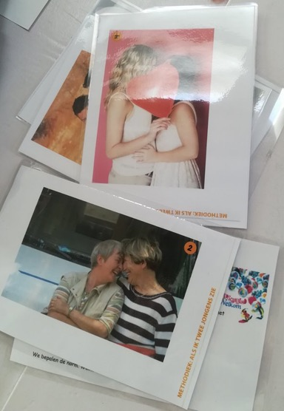

When I see this picture, I think…….

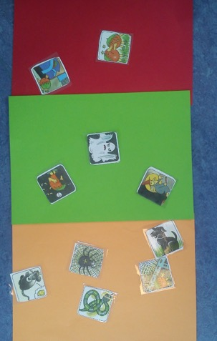
Exploring psychological topics through the media, actions, exercises like "step into the circle", exercises about feelings.
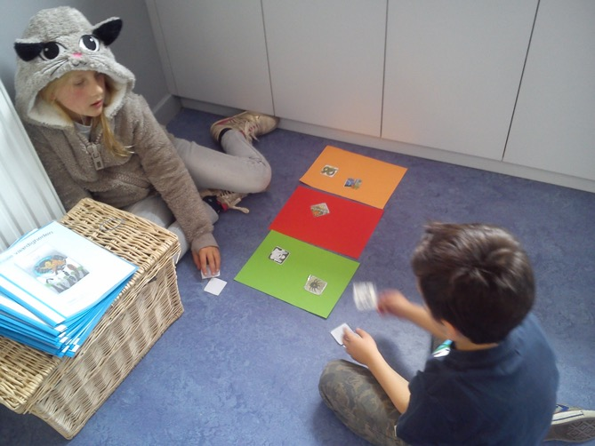

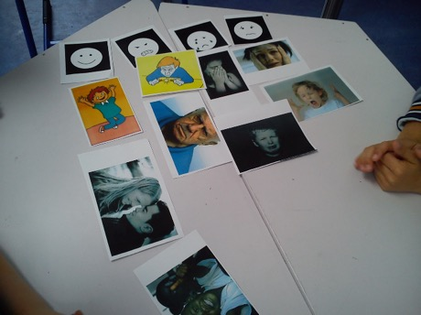

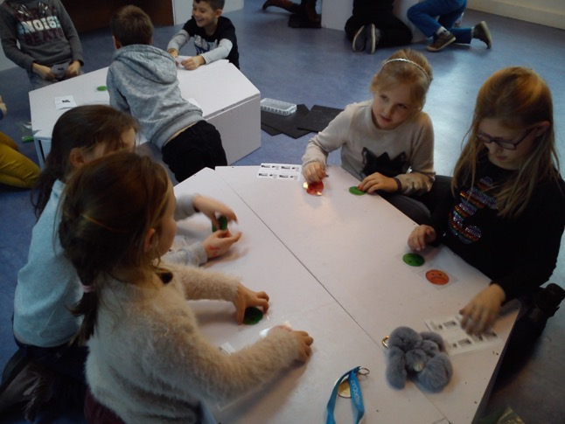

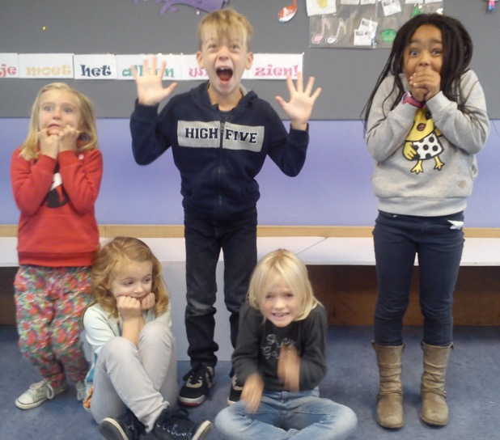

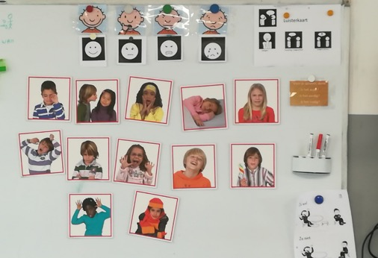

Talentwork", gaining insight into one’s own potency and offering chances for growth through workshops, making use of expertise of parents and/or grandparents.

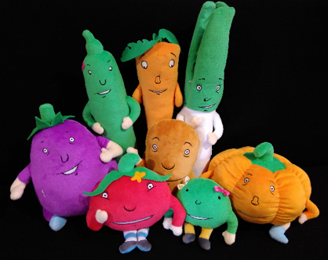
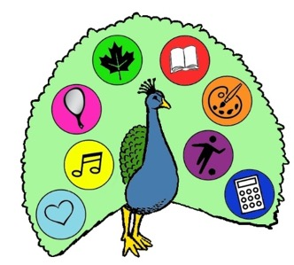

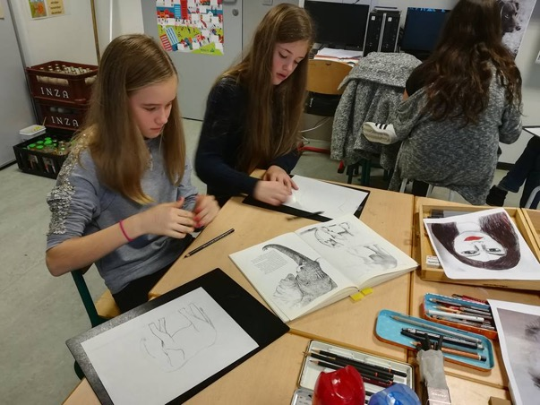
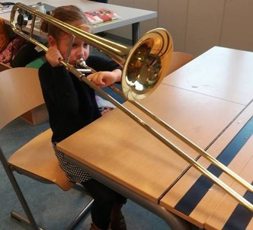

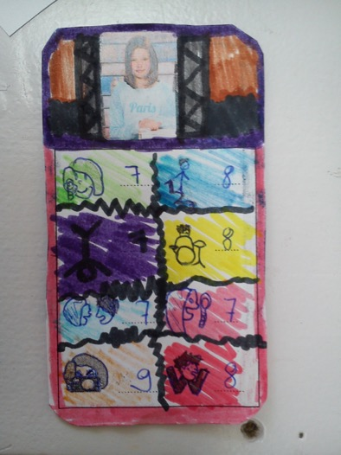
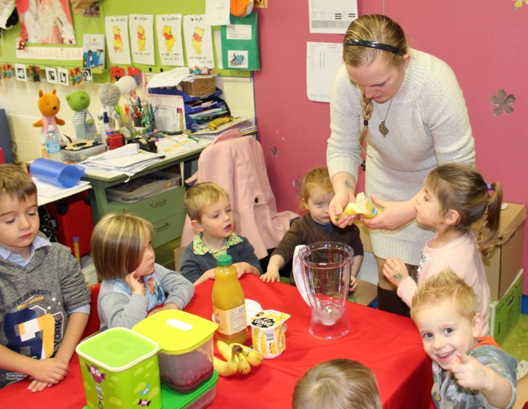

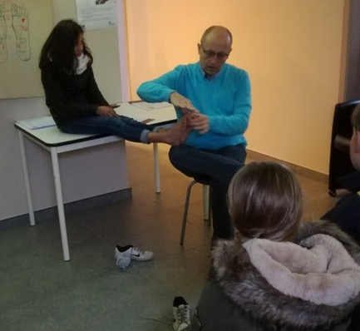

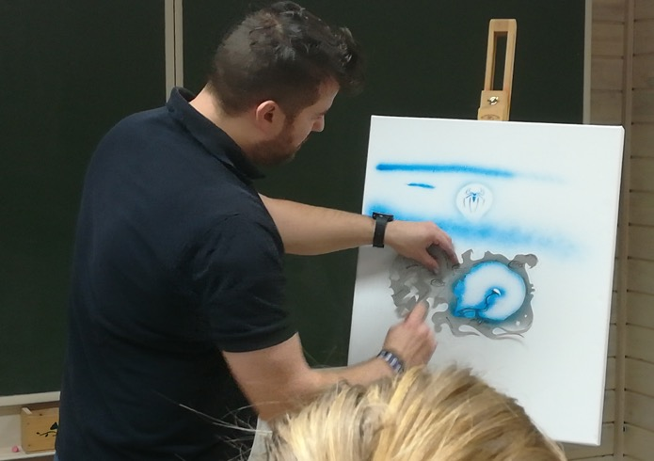

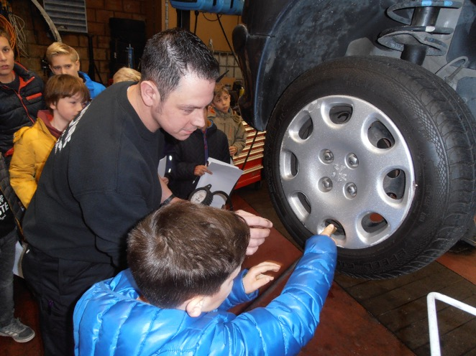

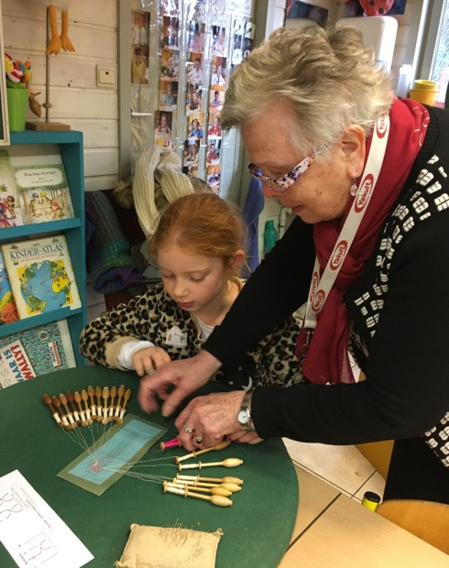

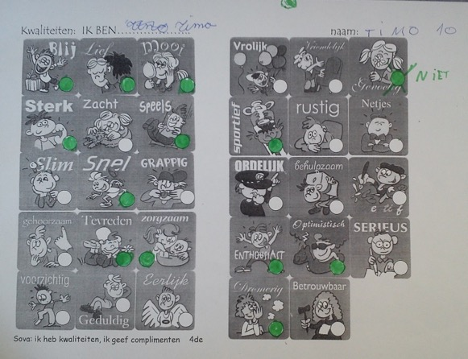
Compliments

Picture
Create an open mind: open for spirituality from other cultures.

The totem animals and their gifts, a counselor on your path.
